38.51: a) Energy to dissociate an molecule is just 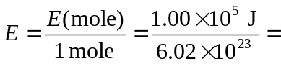
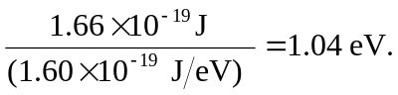
b) 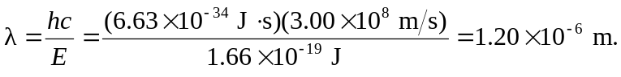
c) 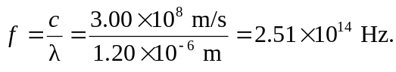
d)
e) Even though a 50-kW radio station emits huge numbers of photons, each individual photon has insufficient energy to dissociate the AgBr molecule. However, the individual photons in faint visible light do have enough energy.

